# 基于TurtleBot3的仿真slam建模与导航(Gazebo建模)

## 前言

* 快速配置环境可以直接看第八章，已经打包好。 前面为分步骤过程，在第四章安装了Cartographer，但因为时间问题，后续没有用，可以跳过。 ## 一、TurtleBot3简介与SLAM简介 {#一-turtlebot3简介与slam简介 } 1、什么是TurtleBot3？ TurtleBot3 是一个小型，低成本，完全可编程，基于 ROS 的移动机器人。它旨在用于教育，研究，产品原型和爱好应用的目的。TurtleBot3 的目标是大幅降低平台的尺寸和价格，而不会牺牲性能，功能和质量。由于提供了其他选项，如底盘，计算机和传感器，TurtleBot3 可以通过各种方式进行定制。TurtleBot3 应用 了SBC（单板计算机），深度传感器和 3D 打印的最新技术进步等技术。 1、什么是SLAM？ 在研究机器人自动行驶的时候，人们注意到，为了实现自动驾驶功能，机器人必须实现对自身的定位和对周围环境的感知。在逐步探索中，研究者开始借用激光雷达、相机等先进的传感设备完成定位与环境感知功能。 同步定位与建图（Simultaneous Localization and Mapping，SLAM）是在上世纪80年代被提出的，起初发展的算法皆采用激光雷达作为定位与建图的工具，随着稀疏性问题的解决，相机也被引入SLAM领域，如今SLAM技术在向多传感器融合的方向发展，激光雷达、深度相机、IMU惯导等正成为SLAM技术的常见解决方案。

## 二、安装ROS

* 本文使用Ubuntu18.04安装ROS Melodic ### 1 . 更改ROS 源(国内源) {#1—更改ros-源国内源 }

sudo sh -c '. /etc/lsb-release && echo "deb http://mirrors.ustc.edu.cn/ros/ubuntu/ $DISTRIB_CODENAME main" > /etc/apt/sources.list.d/ros-latest.list'

### 2.设置密钥

sudo apt-key adv --keyserver hkp://keyserver.ubuntu.com:80 --recv-key 421C365BD9FF1F717815A3895523BAEEB01FA116

### 3.更新软件包列表

sudo apt update

### 4.安装ROS Melodic

sudo apt-get install ros-melodic-desktop-full

### 5.初始化rosdep Shell sudo rosdep init

### 6.更新rosdep Shell sudo rosdep update

### 7.将ros添加到环境变量 Shell echo "source /opt/ros/melodic/setup.bash" >> ~/.bashrc source ~/.bashrc

### 8.运行ROS检测是否安装成功 Shell roscore 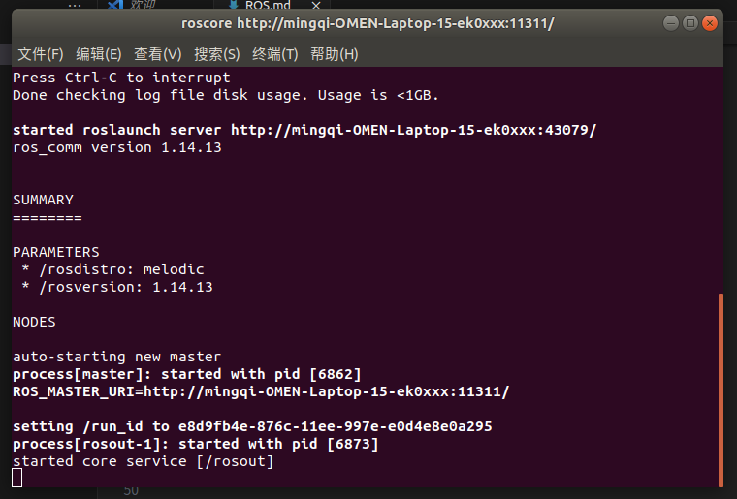 - 如图所示，这ROS Melodic安装成功

## 三、安装Turtlebot3 #### 1.安装Turtlebot3依赖库 {#1安装turtlebot3依赖库 }

sudo apt-get install ros-melodic-joy ros-melodic-teleop-twist-joy ros-melodic-teleop-twist-keyboard ros-melodic-laser-proc ros-melodic-rgbd-launch ros-melodic-depthimage-to-laserscan ros-melodic-rosserial-arduino ros-melodic-rosserial-python ros-melodic-rosserial-server ros-melodic-rosserial-client ros-melodic-rosserial-msgs ros-melodic-amcl ros-melodic-map-server ros-melodic-move-base ros-melodic-urdf ros-melodic-xacro ros-melodic-compressed-image-transport ros-melodic-rqt-image-view ros-melodic-gmapping ros-melodic-navigation ros-melodic-interactive-markers rviz

#### 2.下载Turtlebot3资源包

mkdir -p ~/turtlebot3_ws/src/  
 cd ~/turtlebot3_ws/src/  
 git clone https://github.com/ROBOTIS-GIT/turtlebot3_simulations.git  
 git clone https://github.com/ROBOTIS-GIT/turtlebot3_msgs.git  
 git clone https://github.com/ROBOTIS-GIT/turtlebot3.git

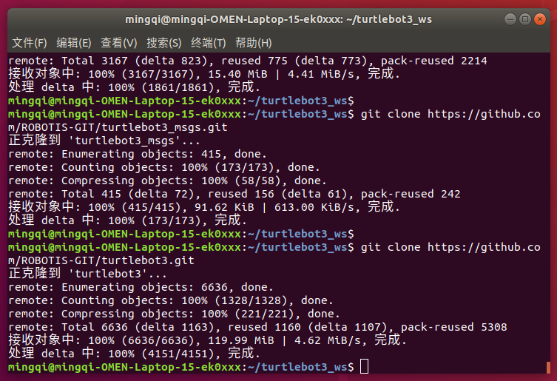 - git Turtlebot3资源包成功

#### 3.编译Turtlebot3资源包

cd ~/turtlebot3_ws  
 catkin_make

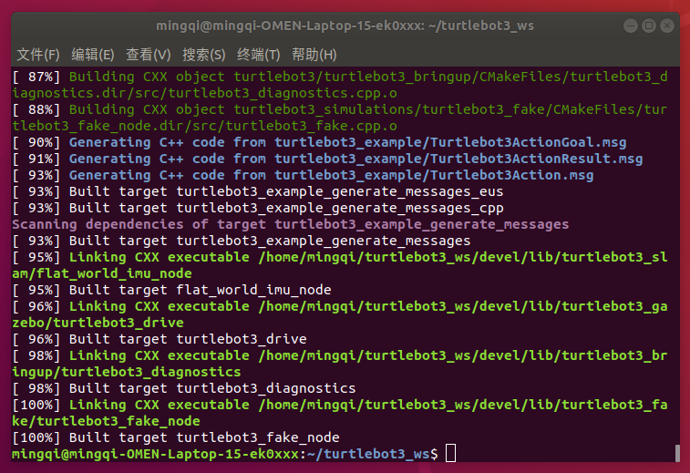

编译成功

### 4.测试Turtlebot3是否安装成功

export TURTLEBOT3_MODEL=burger  
 source ~/turtlebot3_ws/devel/setup.bash   
 roslaunch turtlebot3_fake turtlebot3_fake.launch

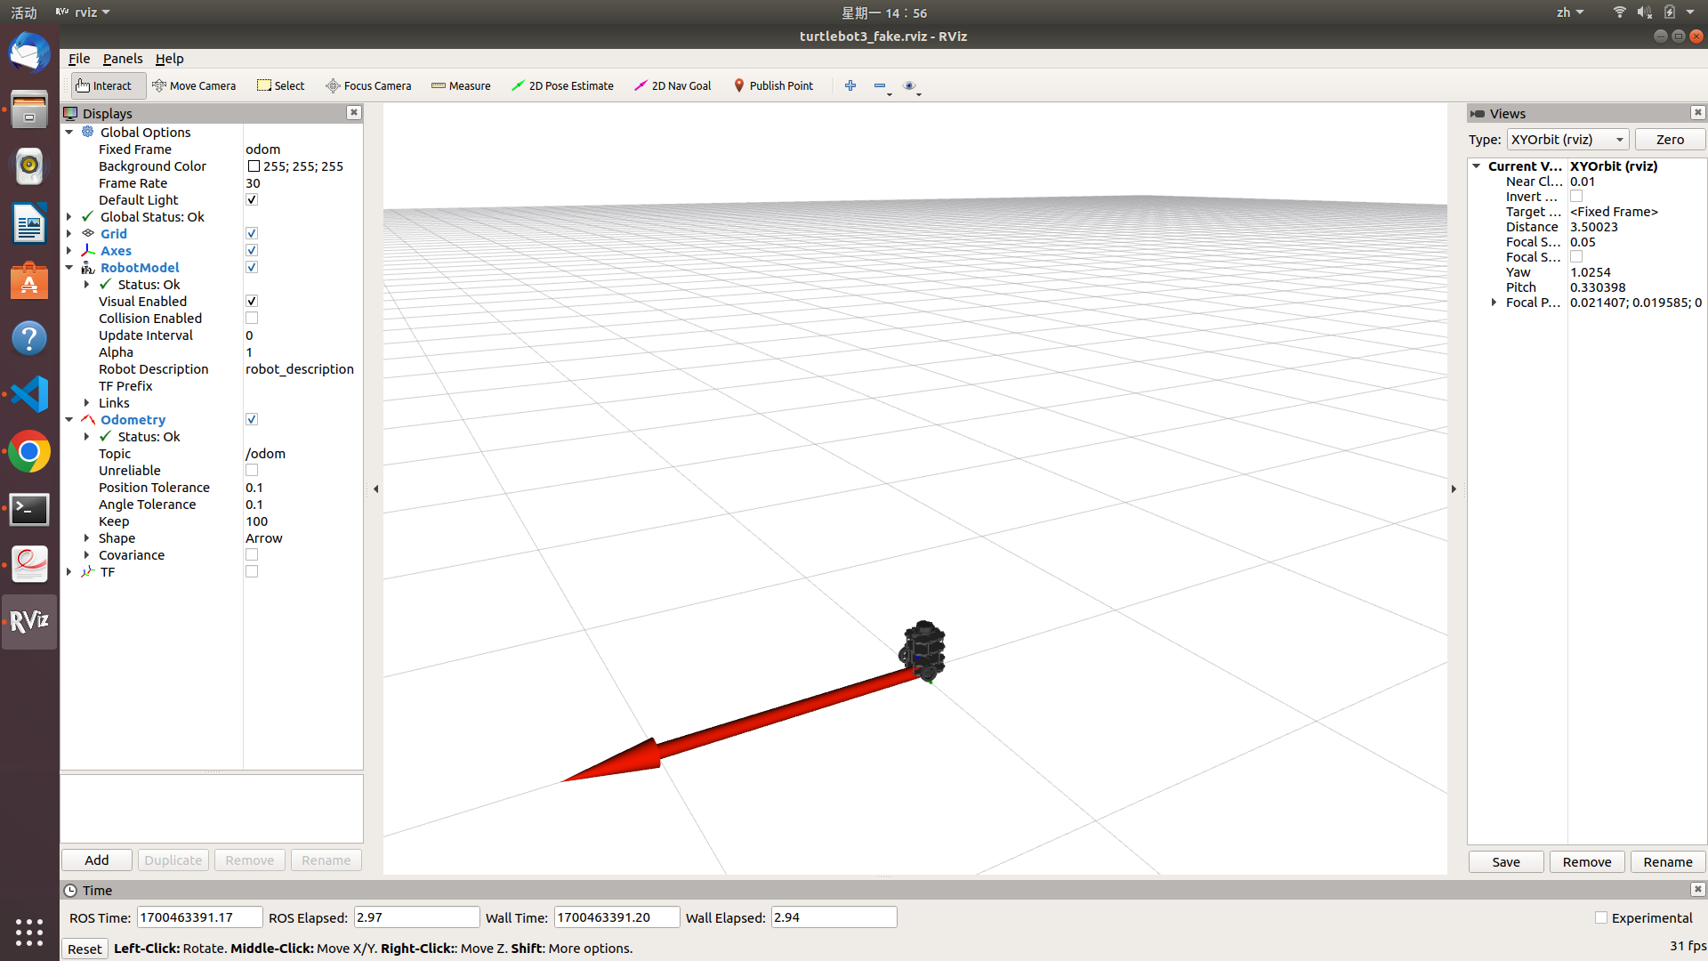

rviz Turtlebot3

### 5.把Turtlebot3加入环境变量

* 打开.bashrc文件

gedit ~/.bashrc

**将下面两行Shell命令拷贝到文件最后**

export TURTLEBOT3_MODEL=burger  
 source ~/turtlebot3_ws/devel/setup.bash

## 四、安装Cartographer

**！！安装Cartographer，需要先升级Cmake**

#### 1、升级Cmake到3.2.0

#先卸载3.10的CMake  
 sudo apt remove cmake  
 #重新安装依赖  
 sudo apt-get install build-essential libssl-dev  
 #下载Cmake3.2.0  
 wget https://github.com/Kitware/CMake/releases/download/v3.20.0/cmake-3.20.0.tar.gz  
 #解压缩  
 tar -zxvf cmake-3.20.0.tar.gz  
 #运行bootstrap脚本  
 cd cmake-3.20.0  
 ./bootstrap  
 #编译安装  
 make   
 sudo make install

* 检测Cmake安装是否成功

cmake --version

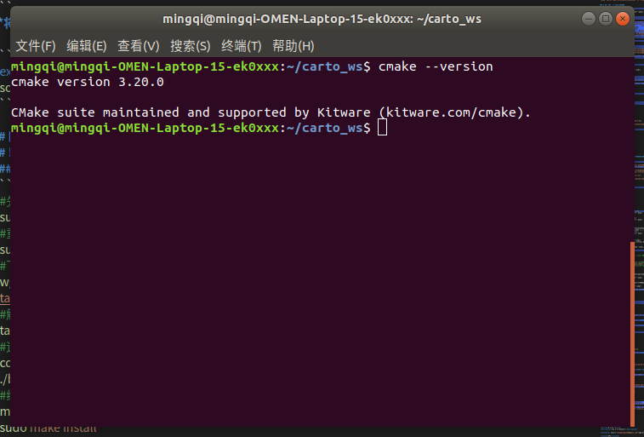 - 安装成功 #### 2、安装Cartographer {#2-安装cartographer } **！！按照**[**Cartographer官网**](https://google-cartographer-ros.readthedocs.io/en/latest/index.html#)**教程安装** - 安装一些工具：wstool, rosdep和Ninja Shell sudo apt-get update sudo apt-get install -y python-wstool python-rosdep ninja-build stow - 安装好这些工具后,创建一个cartographer_ros工作区

#创建文件夹  
 mkdir carto_ws  
 cd carto_ws  
 #下载源码  
 wstool init src  
 wstool merge -t src https://raw.githubusercontent.com/cartographer-project/cartographer_ros/master/cartographer_ros.rosinstall  
 wstool update -t src

* 更改代码，防止后面报错 **打开cartographer/package.xml将第46行 <depend>libabsl-dev</depend> 进行注释**
* 安装依赖项

sudo rosdep init  
 rosdep update  
 rosdep install --from-paths src --ignore-src --rosdistro=${ROS_DISTRO} -y

* 安装abseil-cpp 库

src/cartographer/scripts/install_abseil.sh  
   
 //由于版本冲突，您可能需要卸载ROS abseil-cpp  
 sudo apt-get remove ros-${ROS_DISTRO}-abseil-cpp

* 编译

catkin_make_isolated --install --use-ninja

* 将 cartographer_ws 添加到环境变量中

echo 'source ~/carto_ws/install_isolated/setup.bash' >> ~/.bashrc  
 source ~/.bashrc

#### 3.官方demo验证

* 2D-Demo与结果

#下载demo包  
 wget -P ~/Downloads https://storage.googleapis.com/cartographer-public-data/bags/backpack_2d/cartographer_paper_deutsches_museum.bag  
 #测试  
 roslaunch cartographer_ros demo_backpack_2d.launch bag_filename:=${HOME}/Downloads/cartographer_paper_deutsches_museum.bag

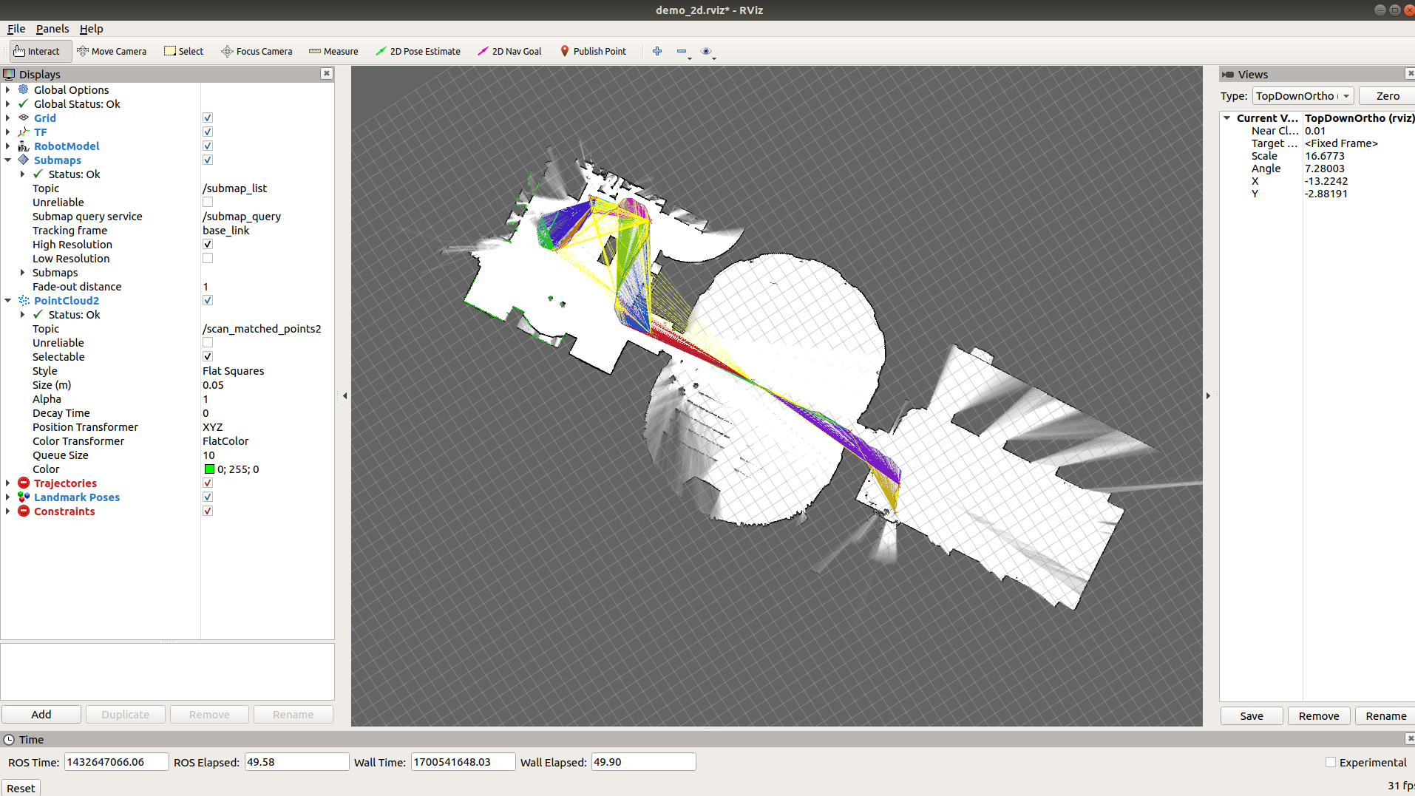

Cartographer

## 五、Gazebo仿真环境搭建

**！！经过测试默认安装的Gazebo9在建立模型放置窗户与门时，会闪退，所以更新为Gazebo11**

# 查看一下Gazebo的插件  
 dpkg -l | grep gazebo  
 # 卸载全部插件  
 sudo apt-get remove gazebo9 gazebo9-common gazebo9-plugin-base libgazebo9:amd64 libgazebo9-dev:amd64 ros-melodic-gazebo-*   
 # 配置镜像  
 sudo sh -c 'echo "deb http://packages.osrfoundation.org/gazebo/ubuntu-stable `lsb_release -cs` main" > /etc/apt/sources.list.d/gazebo-stable.list'   
 #查看文件写入是否正确  
 cat /etc/apt/sources.list.d/gazebo-stable.list   
 #设置Key  
 wget https://packages.osrfoundation.org/gazebo.key -O - | sudo apt-key add -   
 #更新  
 sudo apt-get update  
 #下载、安装Gazebo 11  
 sudo apt-get install gazebo11  
 sudo apt-get install libgazebo11-dev  
 #安装Gazebo的Ros插件  
 sudo apt install ros-melodic-gazebo11-*  
 #检查是否安装成功，直接打开Gazebo即可  
 gazebo

#### 1.打开Gazebo

gazebo

#### 2. 打开建筑编辑器

点击上方“Edit”中“Buiding Edit ”进入建筑编辑器。 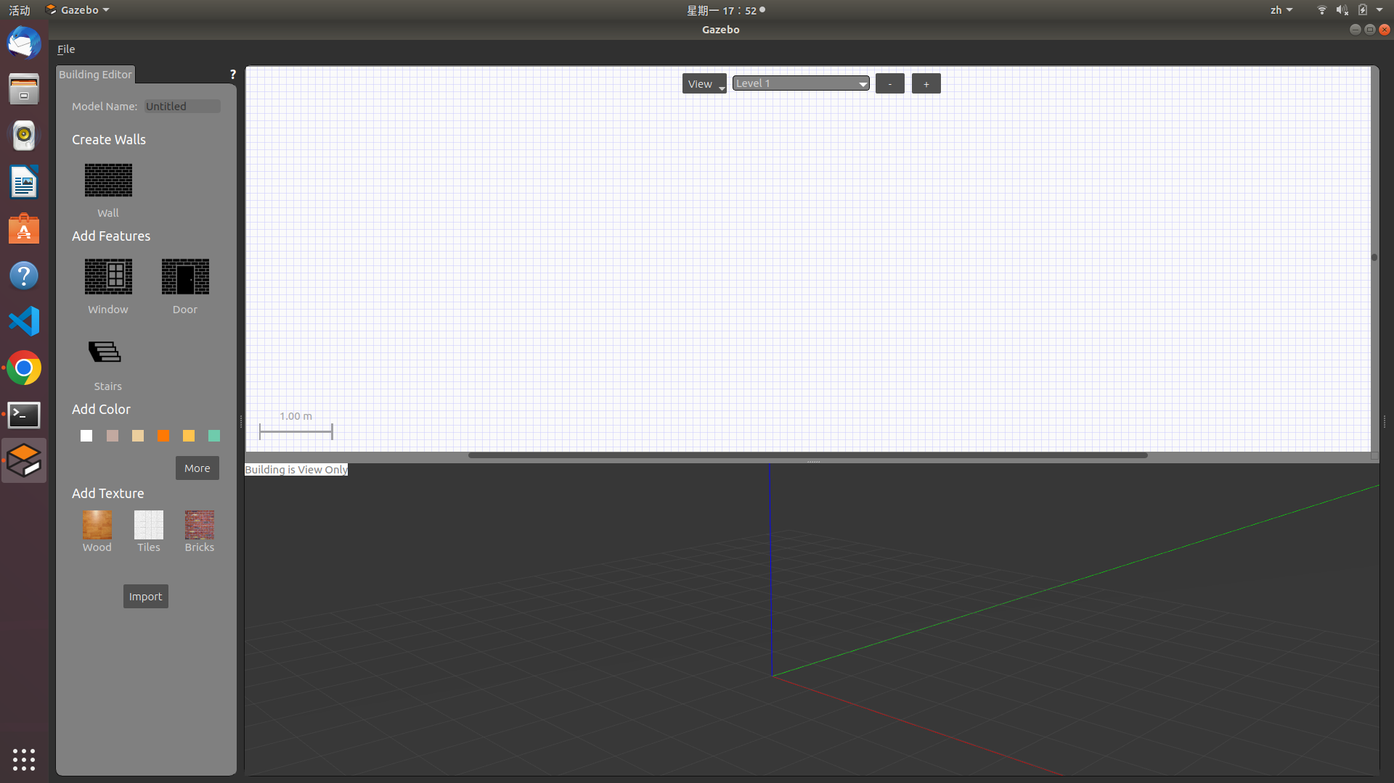

#### 3.用户型图作为参考

点击左下角“import” ，选择一张户型照片导入。 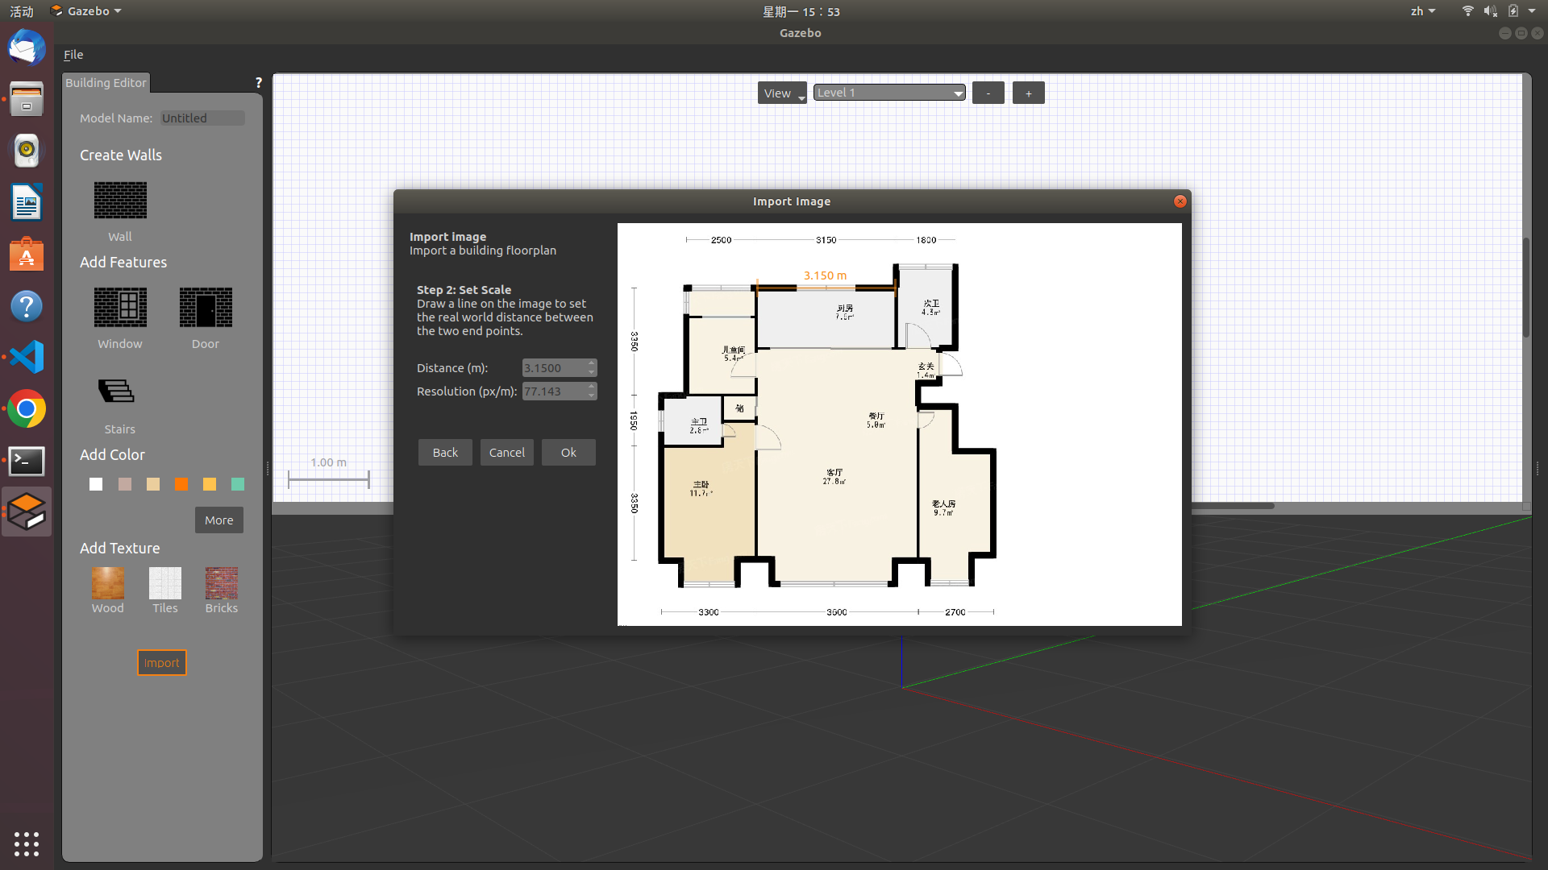 **户型图如下** 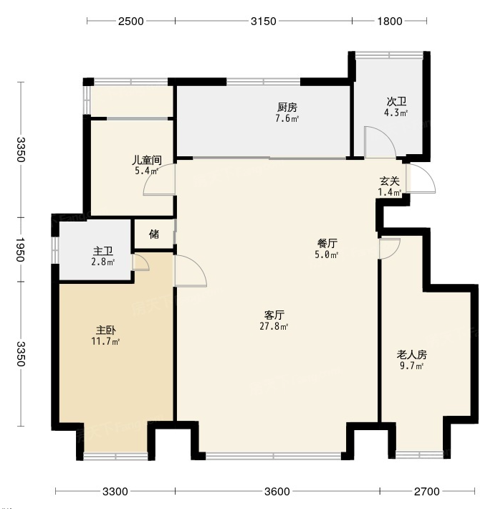

#### 4.创建模型

* 点击左边“ Wall ” ，对着房屋轮廓和内部墙壁描边，下方的3D视图会同步显示墙壁信息。
* 再按照户型图进行门窗的设置，点击左边的“Window ” 和 “ Door ” ，在相应墙壁位置选择即可。
* **可以双击2D视图里的墙壁进行详细参数设置。** 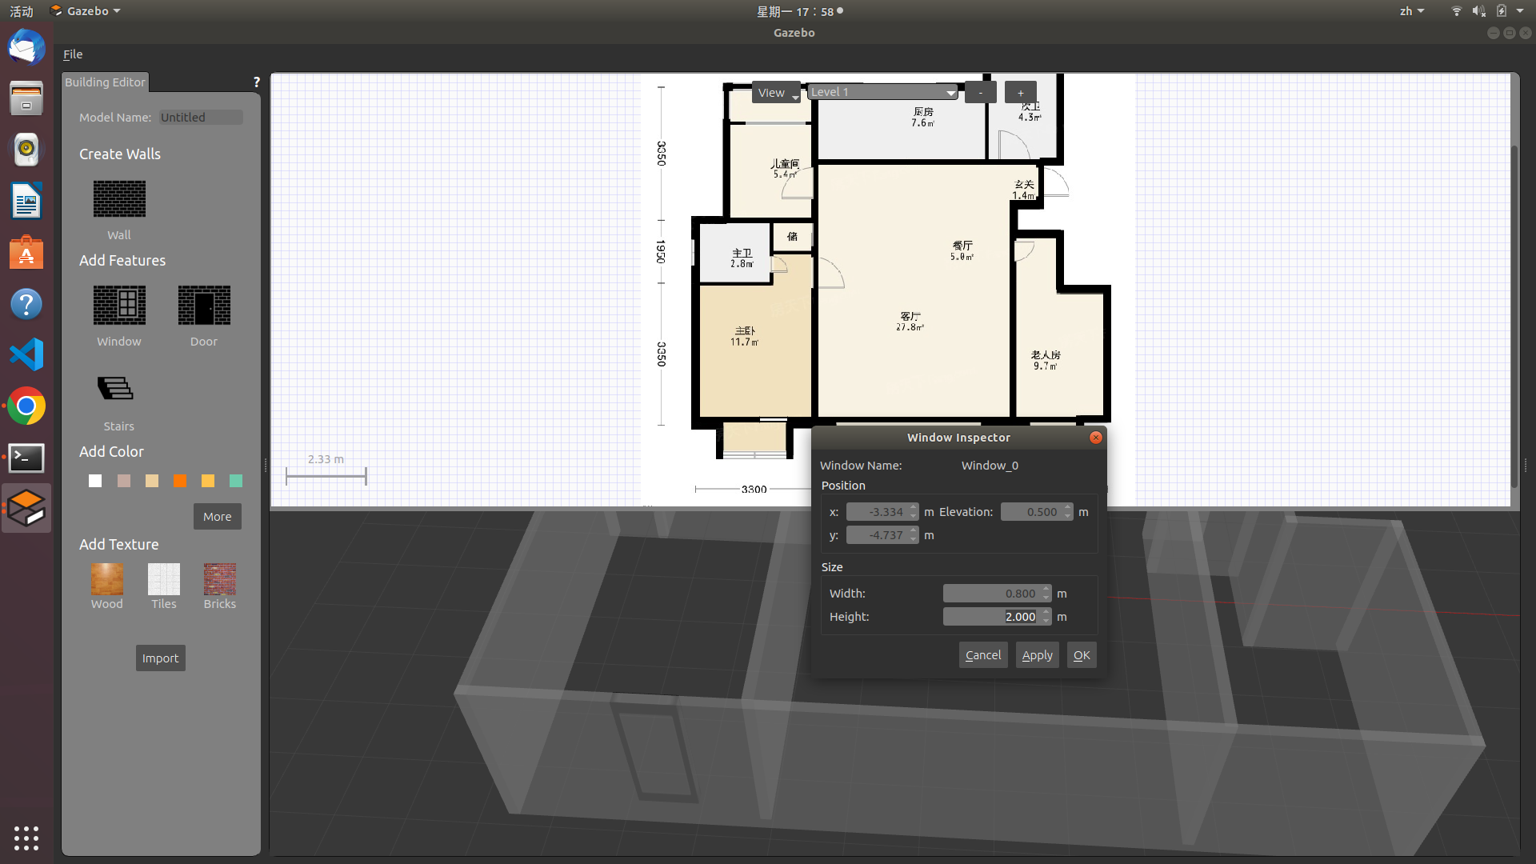

#### 5.保存模型

如图，完成模型绘制。 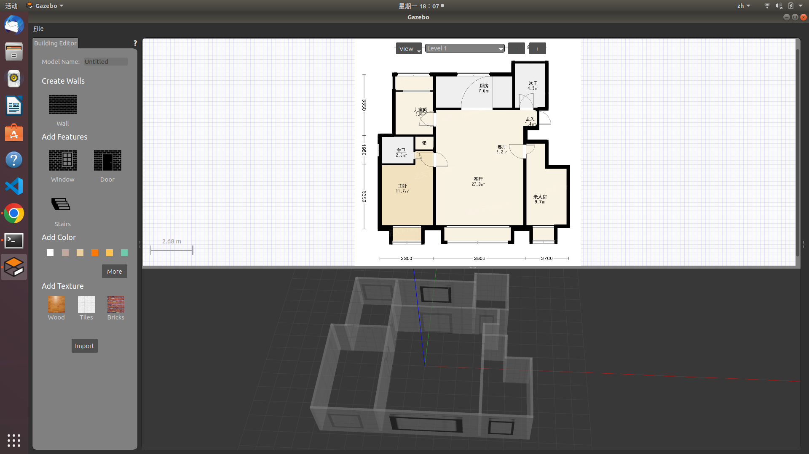 点击左上角“File” → “Save” 保存, 保存为model.config和model.sdf文件。

#### 6.生成.world文件

在gazebo_mode文件中有三个模型，但因为我的电脑性能不行，导入就卡顿，所以用了gazebo的库。

* ganzebo库安装

# 进入.gazebo文件夹，用于存放Gazebo模型和相关配置文件  
 cd ~/.gazebo/  
 # 安装Git工具  
 sudo apt install git  
 # 从https://gitee.com/dva7777/gazebo_models.git克隆Gazebo模型  
 git clone https://gitee.com/dva7777/gazebo_models.git  
 # 将克隆的gazebo_models文件夹重命名为models，并放到.gazebo文件夹下  
 mv gazebo_models/ ./models

* 放置房间模型 再次打开gazebo ，左上角insert 选项卡里就会找到自己的模型，找到并选择自己刚 才建好的模型放置到右边窗口。 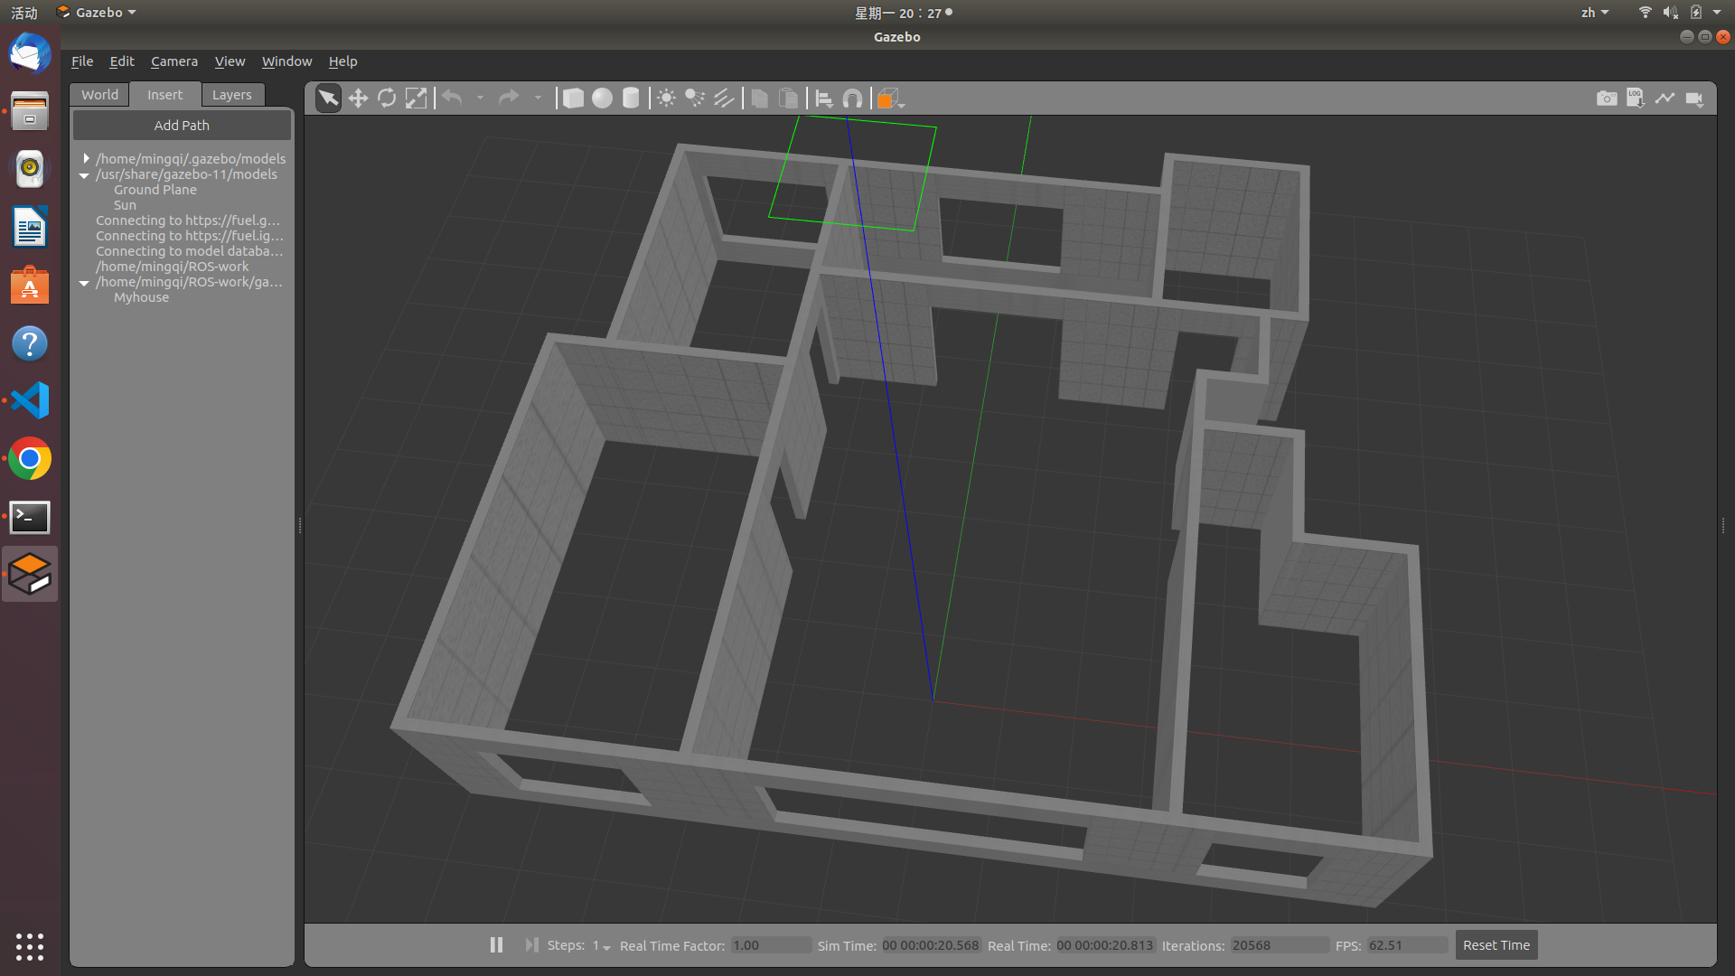
* 放置部分家具 在insert选项下，选择添加自己想要的家具等模型，来丰富自己的world。可以通过上方按钮，来平移、旋转模型选择合适的摆放位置。 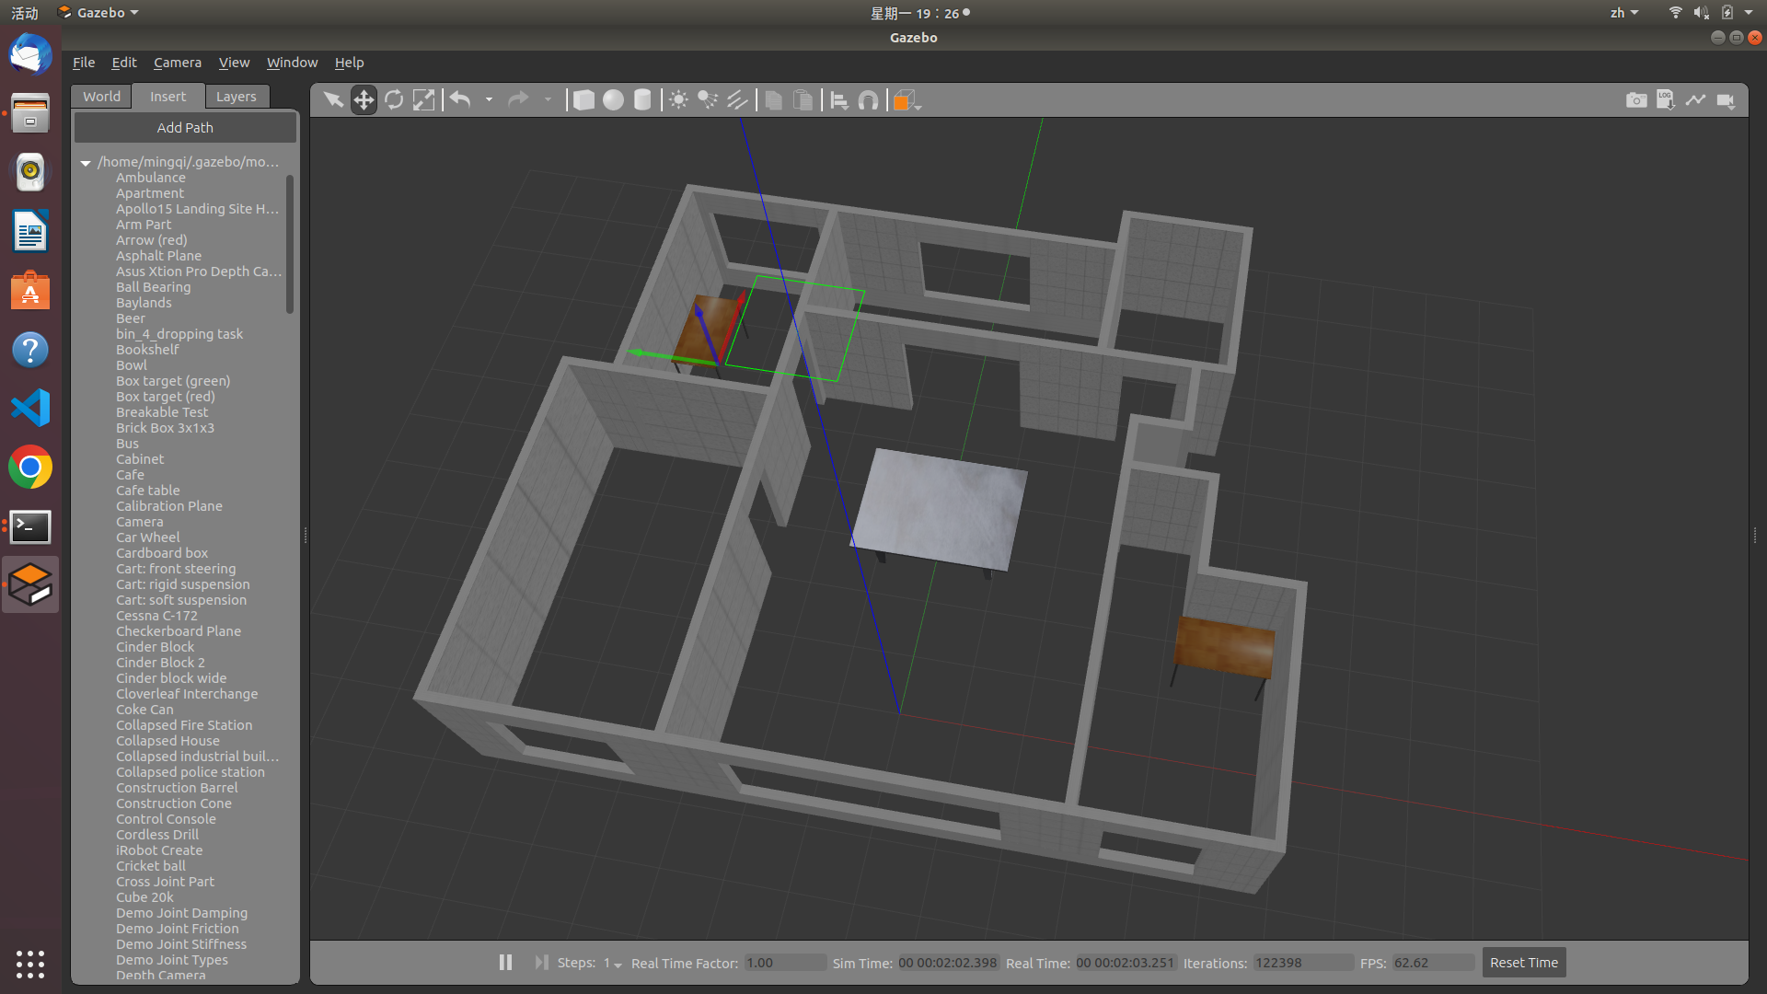
* 点击“File”中“Save world” ，保存到 .world文件 下，并命名为Myhouse.world。

## 六、配置ROS工作工作空间

#### 1.创建ROS工作空间

#创建文件夹  
 mkdir -p ~/roshomework/src  
 cd roshomework/src  
 # ROS的工作空间初始化命令  
 catkin_init_workspace  
 cd ..  
 # 编译整个工作空间  
 catkin_make  
 #配置文件中加入环境变量  
 echo "source ~/roshomework/devel/setup.bash" >> ~/.bashrc

***可以将ros-w的压缩包解压，把所有文件放入oshomework/src中*。省略以下部分至下一章节**

**在roshomework/src建立三个文件夹，分别为launch、src和worlds。再创建一个包清单的package.xml文件**

touch ~/roshomework/src/package.xml  
 mkdir ~/roshomework/src/launch  
 mkdir ~/roshomework/src/src  
 mkdir ~/roshomework/src/words

#### 2.导入.world文件 - 创建gazebo_world文件夹

mkdir ~/roshomework/src/worlds/gazebo_world

* **将第四章-6中生成的Myhouse.world放入gazebo_world文件夹中**

#### 3.编写launch文件 - 参考turtlebot3_world.launch文件编写

* **新建.launch文件**

touch ~/roshomework/src/launch/ turtlebot3_world.launch

* **将下面程序复制到turtlebot3_world.launch文件中**

<launch>  
 <arg name="model" default="$(env TURTLEBOT3_MODEL)" doc="model type [burger, waffle, waffle_pi]"/>  
 <arg name="x_pos" default="0.0"/>  
 <arg name="y_pos" default="0.0"/>  
 <arg name="z_pos" default="0.0"/>  
   
 <include file="$(find gazebo_ros)/launch/empty_world.launch">  
 <arg name="world_name" value="$(find ros-w)/worlds/gazebo_world/Myhouse.world"/>  
 <arg name="paused" value="false"/>  
 <arg name="use_sim_time" value="true"/>  
 <arg name="gui" value="true"/>  
 <arg name="headless" value="false"/>  
 <arg name="debug" value="false"/>  
 </include>  
   
 <param name="robot_description" command="$(find xacro)/xacro --inorder $(find turtlebot3_description)/urdf/turtlebot3_$(arg model).urdf.xacro" />  
   
 <node pkg="gazebo_ros" type="spawn_model" name="spawn_urdf" args="-urdf -model turtlebot3_$(arg model) -x $(arg x_pos) -y $(arg y_pos) -z $(arg z_pos) -param robot_description" />  
</launch>

#### 4. 编写package.xml文件

* **将下列程序复制到package.xml中**

<?xml version="1.0"?>  
<package format="2">  
 <name>ros-w</name>  
 <version>0.1.0</version>  
 <description>zmq wrh homework</description>  
   
 <maintainer email="zhangmingqi318@gmail.com">zmq wrh</maintainer>  
   
 <license>GPL</license>  
   
 <buildtool_depend>catkin</buildtool_depend>  
 <build_depend>rospy</build_depend>  
 <build_export_depend>rospy</build_export_depend>  
 <exec_depend>rospy</exec_depend>  
 <exec_depend>gazebo_ros</exec_depend>  
   
 <export>  
 <gazebo_ros gazebo_media_path="${prefix}/worlds"/>  
 </export>  
</package>

#### 5.更改Turtlebot3类型

* 打开.bashrc文件

gedit ~/.bashrc

**将下TURTLEBOT3_MODEL=burger改为export TURTLEBOT3_MODEL=waffle**

#原为burger  
 export TURTLEBOT3_MODEL=burger  
 #改为waffle  
 export TURTLEBOT3_MODEL=waffle

#### 6.测试工作空间是否建立

roslaunch ros-w turtlebot3_world.launch

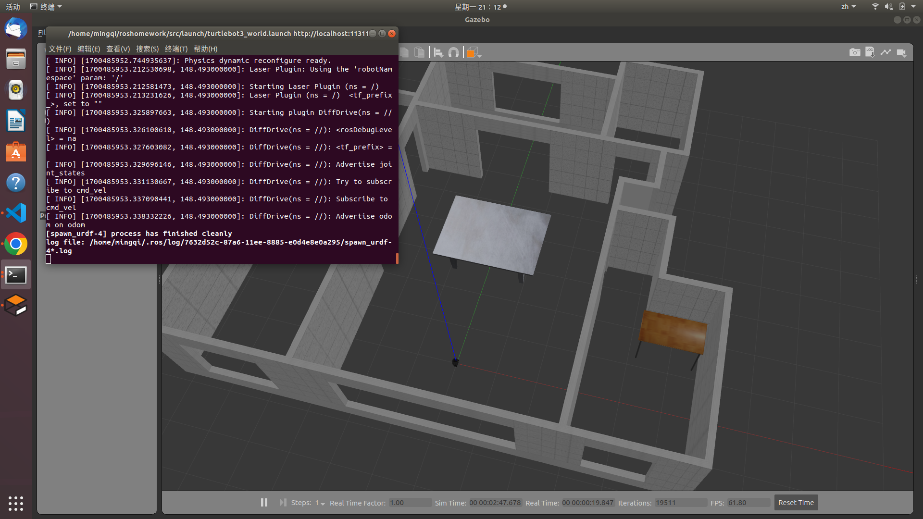

roslaunch测试

## 七、程序编写

#### 1、编写键盘控制程序

* 在 ~/roshomework/src/src中创建控制小车的Python的程序（参考turtlebot3_teleop_key程序）

touch ~/roshomework/src/src/rosw_teleop_key.py

* 下列代码复制进入.py文件中

#!/usr/bin/env python  
   
import rospy  
from geometry_msgs.msg import Twist  
import sys, select, os  
if os.name == 'nt':  
 import msvcrt, time  
else:  
 import tty, termios  
   
BURGER_MAX_LIN_VEL = 0.22  
BURGER_MAX_ANG_VEL = 2.84  
   
WAFFLE_MAX_LIN_VEL = 0.26  
WAFFLE_MAX_ANG_VEL = 1.82  
   
LIN_VEL_STEP_SIZE = 0.01  
ANG_VEL_STEP_SIZE = 0.1  
   
msg = """  
Control Your TurtleBot3!  
---------------------------  
Moving around:  
 w  
 a s d  
 x  
   
w/x : increase/decrease linear velocity (Burger : ~ 0.22, Waffle and Waffle Pi : ~ 0.26)  
a/d : increase/decrease angular velocity (Burger : ~ 2.84, Waffle and Waffle Pi : ~ 1.82)  
   
space key, s : force stop  
   
CTRL-C to quit  
"""  
   
e = """  
Communications Failed  
"""  
   
def getKey():  
 if os.name == 'nt':  
 timeout = 0.1  
 startTime = time.time()  
 while(1):  
 if msvcrt.kbhit():  
 if sys.version_info[0] >= 3:  
 return msvcrt.getch().decode()  
 else:  
 return msvcrt.getch()  
 elif time.time() - startTime > timeout:  
 return ''  
   
 tty.setraw(sys.stdin.fileno())  
 rlist, _, _ = select.select([sys.stdin], [], [], 0.1)  
 if rlist:  
 key = sys.stdin.read(1)  
 else:  
 key = ''  
   
 termios.tcsetattr(sys.stdin, termios.TCSADRAIN, settings)  
 return key  
   
def vels(target_linear_vel, target_angular_vel):  
 return "currently:\tlinear vel %s\t angular vel %s " % (target_linear_vel,target_angular_vel)  
   
def makeSimpleProfile(output, input, slop):  
 if input > output:  
 output = min( input, output + slop )  
 elif input < output:  
 output = max( input, output - slop )  
 else:  
 output = input  
   
 return output  
   
def constrain(input, low, high):  
 if input < low:  
 input = low  
 elif input > high:  
 input = high  
 else:  
 input = input  
   
 return input  
   
def checkLinearLimitVelocity(vel):  
 if turtlebot3_model == "burger":  
 vel = constrain(vel, -BURGER_MAX_LIN_VEL, BURGER_MAX_LIN_VEL)  
 elif turtlebot3_model == "waffle" or turtlebot3_model == "waffle_pi":  
 vel = constrain(vel, -WAFFLE_MAX_LIN_VEL, WAFFLE_MAX_LIN_VEL)  
 else:  
 vel = constrain(vel, -BURGER_MAX_LIN_VEL, BURGER_MAX_LIN_VEL)  
   
 return vel  
   
def checkAngularLimitVelocity(vel):  
 if turtlebot3_model == "burger":  
 vel = constrain(vel, -BURGER_MAX_ANG_VEL, BURGER_MAX_ANG_VEL)  
 elif turtlebot3_model == "waffle" or turtlebot3_model == "waffle_pi":  
 vel = constrain(vel, -WAFFLE_MAX_ANG_VEL, WAFFLE_MAX_ANG_VEL)  
 else:  
 vel = constrain(vel, -BURGER_MAX_ANG_VEL, BURGER_MAX_ANG_VEL)  
   
 return vel  
   
if __name__=="__main__":  
 if os.name != 'nt':  
 settings = termios.tcgetattr(sys.stdin)  
   
 rospy.init_node('turtlebot3_teleop')  
 pub = rospy.Publisher('cmd_vel', Twist, queue_size=10)  
   
 turtlebot3_model = rospy.get_param("model", "burger")  
   
 status = 0  
 target_linear_vel = 0.0  
 target_angular_vel = 0.0  
 control_linear_vel = 0.0  
 control_angular_vel = 0.0  
   
 try:  
 print(msg)  
 while not rospy.is_shutdown():  
 key = getKey()  
 if key == 'w' :  
 target_linear_vel = checkLinearLimitVelocity(target_linear_vel + LIN_VEL_STEP_SIZE)  
 status = status + 1  
 print(vels(target_linear_vel,target_angular_vel))  
 elif key == 'x' :  
 target_linear_vel = checkLinearLimitVelocity(target_linear_vel - LIN_VEL_STEP_SIZE)  
 status = status + 1  
 print(vels(target_linear_vel,target_angular_vel))  
 elif key == 'a' :  
 target_angular_vel = checkAngularLimitVelocity(target_angular_vel + ANG_VEL_STEP_SIZE)  
 status = status + 1  
 print(vels(target_linear_vel,target_angular_vel))  
 elif key == 'd' :  
 target_angular_vel = checkAngularLimitVelocity(target_angular_vel - ANG_VEL_STEP_SIZE)  
 status = status + 1  
 print(vels(target_linear_vel,target_angular_vel))  
 elif key == ' ' or key == 's' :  
 target_linear_vel = 0.0  
 control_linear_vel = 0.0  
 target_angular_vel = 0.0  
 control_angular_vel = 0.0  
 print(vels(target_linear_vel, target_angular_vel))  
 else:  
 if (key == '\x03'):  
 break  
   
 if status == 20 :  
 print(msg)  
 status = 0  
   
 twist = Twist()  
   
 control_linear_vel = makeSimpleProfile(control_linear_vel, target_linear_vel, (LIN_VEL_STEP_SIZE/2.0))  
 twist.linear.x = control_linear_vel; twist.linear.y = 0.0; twist.linear.z = 0.0  
   
 control_angular_vel = makeSimpleProfile(control_angular_vel, target_angular_vel, (ANG_VEL_STEP_SIZE/2.0))  
 twist.angular.x = 0.0; twist.angular.y = 0.0; twist.angular.z = control_angular_vel  
   
 pub.publish(twist)  
   
 except:  
 print(e)  
   
 finally:  
 twist = Twist()  
 twist.linear.x = 0.0; twist.linear.y = 0.0; twist.linear.z = 0.0  
 twist.angular.x = 0.0; twist.angular.y = 0.0; twist.angular.z = 0.0  
 pub.publish(twist)  
   
 if os.name != 'nt':  
 termios.tcsetattr(sys.stdin, termios.TCSADRAIN, settings)

**为Python赋权，防止后期报错**

chmod 777 ~/roshomework/src/src/rosw_teleop_key.py

#### 2、slam建模

**借用turtlebot3_slam程序**

#打开模型  
 roslaunch ros-w turtlebot3_world.launch  
 #新建终端 运行键盘控制程序  
 rosrun ros-w rosw_teleop_key.py  
 #新建终端 运行turtlebot3_slam.launch来slam建模  
 roslaunch turtlebot3_slam turtlebot3_slam.launch

* 通过键盘操控小车构建地图，如下图 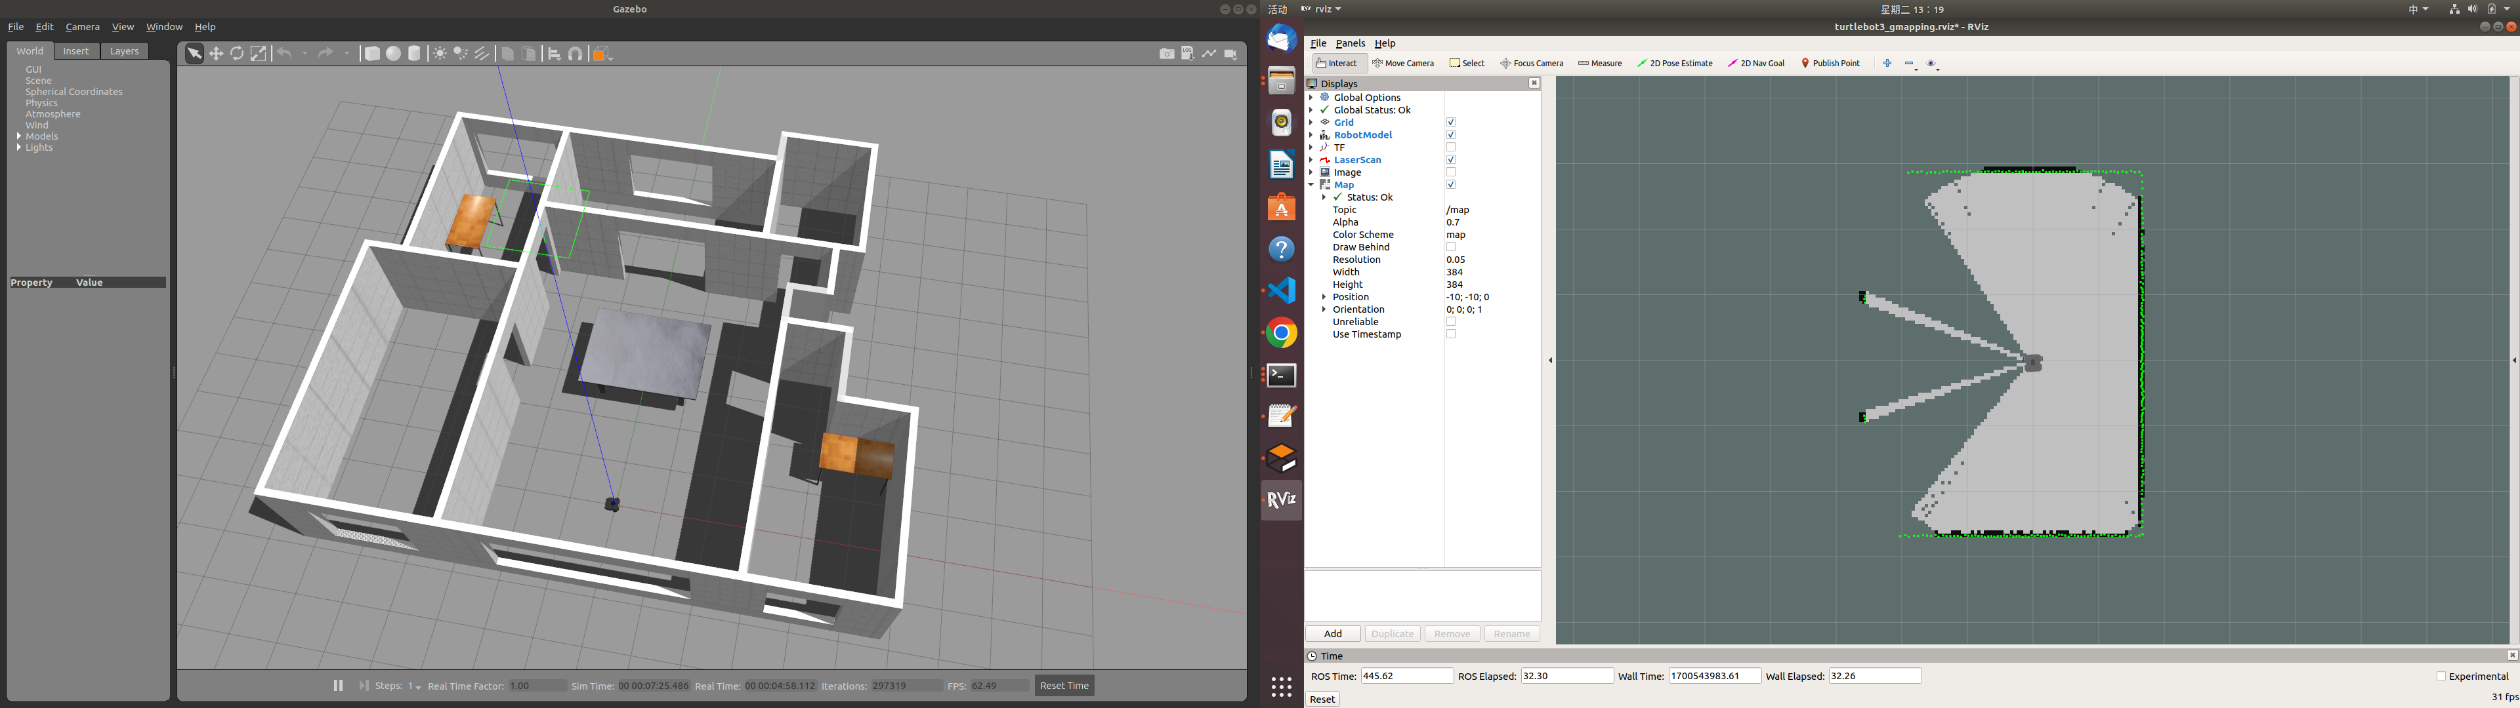
* 构建完地图 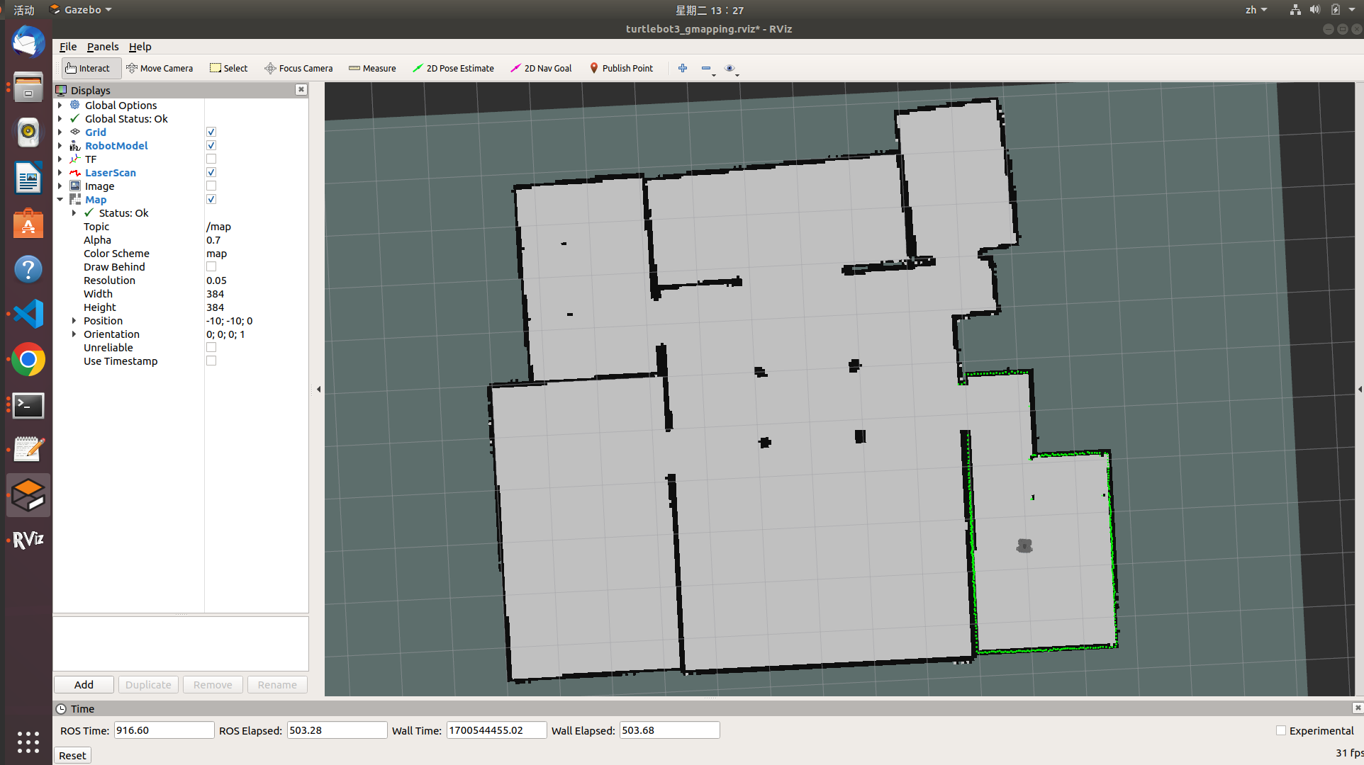
* **启动map_server，保存地图（pgm和yaml）**

rosrun map_server map_saver -f /home/mingqi/roshomework/src/map/map

**为地图赋权，防止后期报错**

chmod 777 ~/roshomework/src/map/map.yaml

#### 3、slam自主导航

**借用turtlebot3_slam程序**

#加载仿真环境  
 roslaunch ros-w turtlebot3_world.launch   
#加载导航节点  
 roslaunch turtlebot3_navigation turtlebot3_navigation.launch map_file:=/home/mingqi/roshomework/src/map/map.yaml

* 配置好rviz,使用2D Pose Estimate设定好小车起始地点，再使用2D Nav Goal设定小车目标地点，小车会规划好路径，自动运行到目标位置，实现自主导航功能。 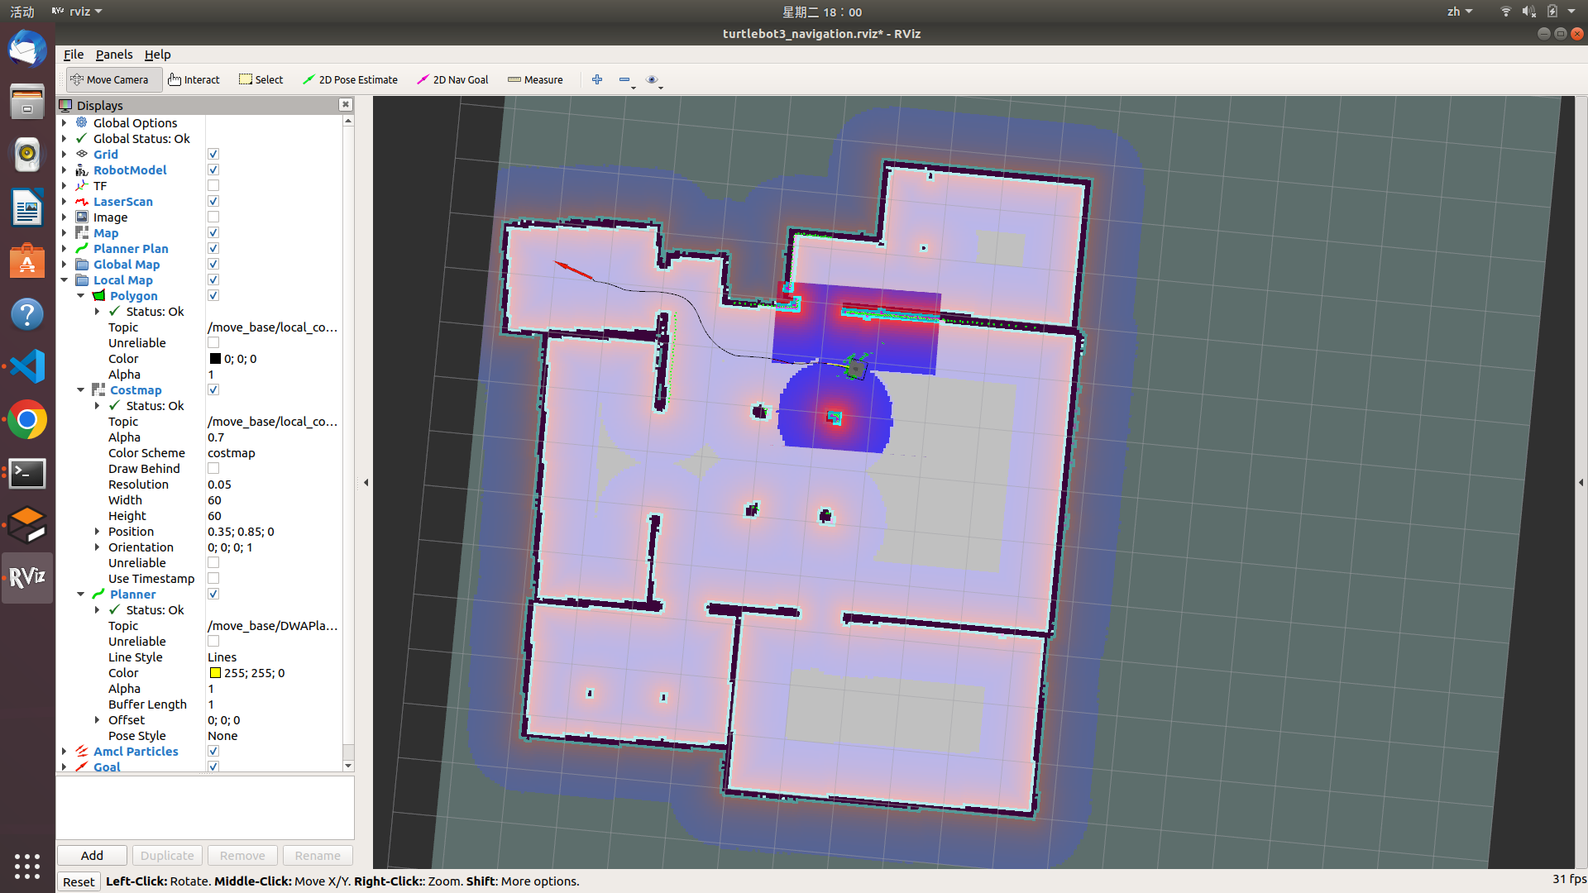

#### 4、整合launch文件

整合launch文件，一共分为五个： 1.仿真环境（turtlebot3_world.launch） 2.仿真环境+键盘控制（turtlebot3_control.launch） 3.仿真环境+键盘控制+激光rviz（turtlebot3_control_laser.launch） 4.仿真环境+slam建模（turtlebot3_slam.launch） 5.仿真环境+slam导航（turtlebot3_guidance.launch）

* **1.仿真环境（turtlebot3_world.launch）** 上文已经配置好

turtlebot3_world.launch

节点图如下： 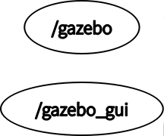

* **2.仿真环境+键盘控制（turtlebot3_control.launch）** 加入键盘控制节点

#新建launch文件  
 touch ~/roshomework/src/launch/turtlebot3_control.launch  
 #授权  
 chmod 777 ~/roshomework/src/launch/turtlebot3_control.launch  
 #文本编辑器打开  
 gedit ~/roshomework/src/launch/turtlebot3_control.launch

**将下面程序复制到turtlebot3_control.launch文件中**

<launch>  
 <arg name="model" default="$(env TURTLEBOT3_MODEL)" doc="model type [burger, waffle, waffle_pi]"/>  
 <arg name="x_pos" default="0.0"/>  
 <arg name="y_pos" default="0.0"/>  
 <arg name="z_pos" default="0.0"/>  
   
 <include file="$(find gazebo_ros)/launch/empty_world.launch">  
 <arg name="world_name" value="$(find ros-w)/worlds/gazebo_world/Myhouse.world"/>  
 <arg name="paused" value="false"/>  
 <arg name="use_sim_time" value="true"/>  
 <arg name="gui" value="true"/>  
 <arg name="headless" value="false"/>  
 <arg name="debug" value="false"/>  
 </include>  
   
 <param name="robot_description" command="$(find xacro)/xacro --inorder $(find turtlebot3_description)/urdf/turtlebot3_$(arg model).urdf.xacro" />  
   
 <node pkg="gazebo_ros" type="spawn_model" name="spawn_urdf" args="-urdf -model turtlebot3_$(arg model) -x $(arg x_pos) -y $(arg y_pos) -z $(arg z_pos) -param robot_description" />  
 <node pkg="ros-w" type="rosw_teleop_key.py" name="control_robot" output="screen" />  
</launch>

节点图如下： 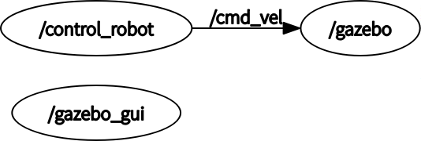

* **3.仿真环境+键盘控制+激光rviz（turtlebot3_control_laser.launch）** 加入键盘控制节点

#新建launch文件  
 touch ~/roshomework/src/launch/turtlebot3_control_laser.launch  
 #授权  
 chmod 777 ~/roshomework/src/launch/turtlebot3_control_laser.launch  
 #文本编辑器打开  
 gedit ~/roshomework/src/launch/turtlebot3_control_laser.launch

**将下面程序复制到turtlebot3_control_laser.launch文件中**

<launch>  
 <arg name="model" default="$(env TURTLEBOT3_MODEL)" doc="model type [burger, waffle, waffle_pi]"/>  
 <arg name="x_pos" default="0.0"/>  
 <arg name="y_pos" default="0.0"/>  
 <arg name="z_pos" default="0.0"/>  
   
 <include file="$(find gazebo_ros)/launch/empty_world.launch">  
 <arg name="world_name" value="$(find ros-w)/worlds/gazebo_world/Myhouse.world"/>  
 <arg name="paused" value="false"/>  
 <arg name="use_sim_time" value="true"/>  
 <arg name="gui" value="true"/>  
 <arg name="headless" value="false"/>  
 <arg name="debug" value="false"/>  
 </include>  
   
 <include file="$(find turtlebot3_gazebo)/launch/turtlebot3_gazebo_rviz.launch">  
 </include>  
   
 <param name="robot_description" command="$(find xacro)/xacro --inorder $(find turtlebot3_description)/urdf/turtlebot3_$(arg model).urdf.xacro" />  
   
 <node pkg="gazebo_ros" type="spawn_model" name="spawn_urdf" args="-urdf -model turtlebot3_$(arg model) -x $(arg x_pos) -y $(arg y_pos) -z $(arg z_pos) -param robot_description" />  
 <node pkg="ros-w" type="rosw_teleop_key.py" name="control_robot" output="screen" />  
</launch>

节点图如下： 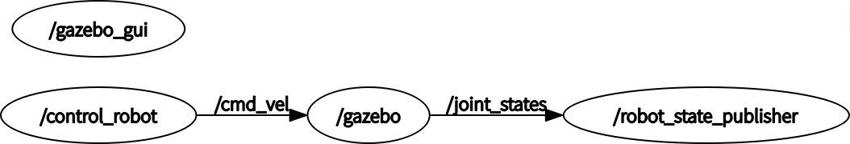

* **4.仿真环境+slam建模（turtlebot3_slam.launch）** 加入键盘控制节点

#新建launch文件  
 touch ~/roshomework/src/launch/turtlebot3_slam.launch  
 #授权  
 chmod 777 ~/roshomework/src/launch/turtlebot3_slam.launch  
 #文本编辑器打开  
 gedit ~/roshomework/src/launch/turtlebot3_slam.launch

**将下面程序复制到turtlebot3_slam.launch文件中**

<launch>  
 <arg name="model" default="$(env TURTLEBOT3_MODEL)" doc="model type [burger, waffle, waffle_pi]"/>  
 <arg name="x_pos" default="0.0"/>  
 <arg name="y_pos" default="0.0"/>  
 <arg name="z_pos" default="0.0"/>  
   
 <include file="$(find gazebo_ros)/launch/empty_world.launch">  
 <arg name="world_name" value="$(find ros-w)/worlds/gazebo_world/Myhouse.world"/>  
 <arg name="paused" value="false"/>  
 <arg name="use_sim_time" value="true"/>  
 <arg name="gui" value="true"/>  
 <arg name="headless" value="false"/>  
 <arg name="debug" value="false"/>  
 </include>  
 <include file="$(find turtlebot3_slam)/launch/turtlebot3_slam.launch">  
 </include>  
   
 <param name="robot_description" command="$(find xacro)/xacro --inorder $(find turtlebot3_description)/urdf/turtlebot3_$(arg model).urdf.xacro" />  
   
 <node pkg="gazebo_ros" type="spawn_model" name="spawn_urdf" args="-urdf -model turtlebot3_$(arg model) -x $(arg x_pos) -y $(arg y_pos) -z $(arg z_pos) -param robot_description" />  
 <node pkg="ros-w" type="rosw_teleop_key.py" name="control_robot" output="screen" />  
</launch>

节点图如下： 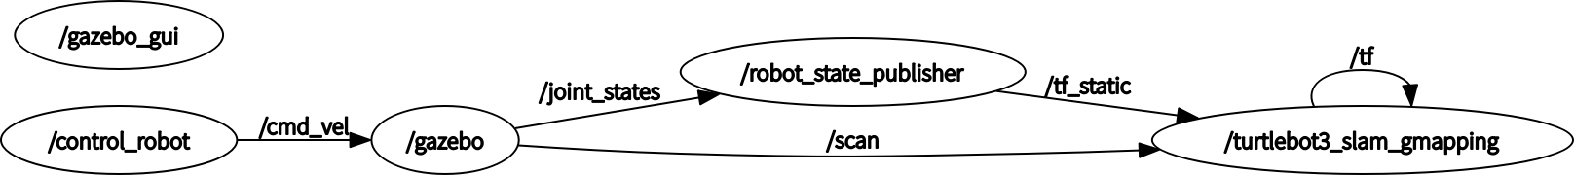

* **5.仿真环境+slam导航（turtlebot3_guidance.launch）** 加入键盘控制节点

#新建launch文件  
 touch ~/roshomework/src/launch/turtlebot3_guidance.launch  
 #授权  
 chmod 777 ~/roshomework/src/launch/turtlebot3_guidance.launch  
 #文本编辑器打开  
 gedit ~/roshomework/src/launch/turtlebot3_guidance.launch

**将下面程序复制到turtlebot3_guidance.launch文件中**

<launch>  
 <arg name="model" default="$(env TURTLEBOT3_MODEL)" doc="model type [burger, waffle, waffle_pi]"/>  
 <arg name="x_pos" default="0.0"/>  
 <arg name="y_pos" default="0.0"/>  
 <arg name="z_pos" default="0.0"/>  
   
 <include file="$(find gazebo_ros)/launch/empty_world.launch">  
 <arg name="world_name" value="$(find ros-w)/worlds/gazebo_world/Myhouse.world"/>  
 <arg name="paused" value="false"/>  
 <arg name="use_sim_time" value="true"/>  
 <arg name="gui" value="true"/>  
 <arg name="headless" value="false"/>  
 <arg name="debug" value="false"/>  
 </include>  
   
 <include file="$(find turtlebot3_navigation)/launch/turtlebot3_navigation.launch">  
 <arg name="map_file" value="$(find ros-w)/map/map.yaml"/>  
 </include>  
   
 <param name="robot_description" command="$(find xacro)/xacro --inorder $(find turtlebot3_description)/urdf/turtlebot3_$(arg model).urdf.xacro" />  
   
 <node pkg="gazebo_ros" type="spawn_model" name="spawn_urdf" args="-urdf -model turtlebot3_$(arg model) -x $(arg x_pos) -y $(arg y_pos) -z $(arg z_pos) -param robot_description" />  
</launch>

节点图如下： 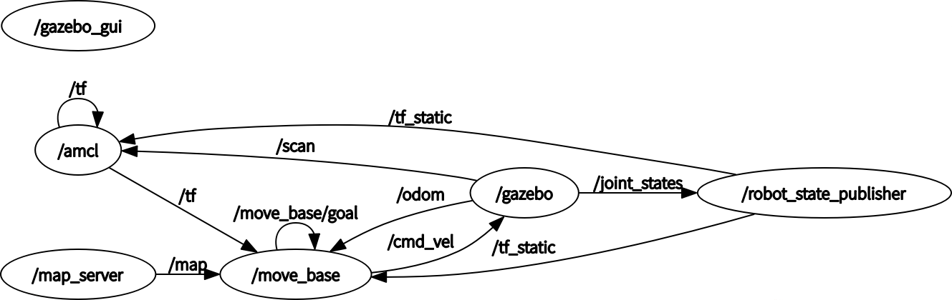

## 八、简易安装OR测试

***所有代码都可以从我的Github中下载：https://github.com/zhuanshunjishi/ROS-work*** ***或在在Gitee中下载：https://gitee.com/MingQi_Ya/ROS-work*** ### 2.方法一(SHELL脚本) {#2方法一shell脚本 }

#返回主目录  
 cd ~  
 #下载shell文件&&执行shell文件  
 git clone https://gitee.com/MingQi_Ya/ROS-work-sh.git && ./ROS-work-sh/roshomework.sh

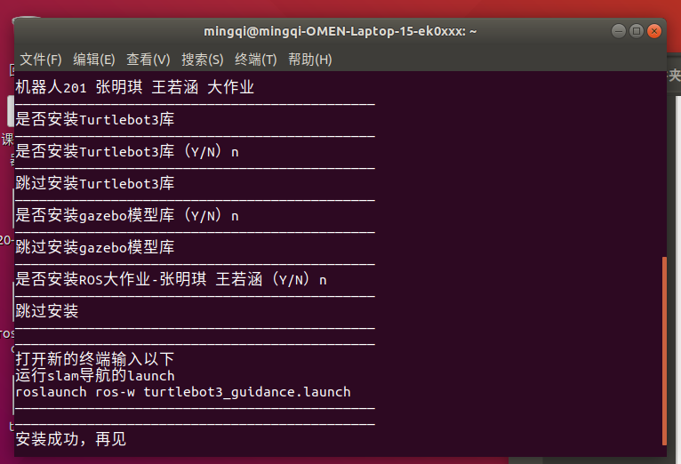

Shell脚本

### 2.方法二

#### 1.安装Turtlebot3

* 因为在后来用Turtlebot3作为载体。 **按照第三章安装Turtlebot3** #### 2.安装gazebo模型库 {#2安装gazebo模型库 }
* 因为在后来的仿真模型（Myhouse.world）中用到了gazebo模型库的模型。

# 进入.gazebo文件夹，用于存放Gazebo模型和相关配置文件  
 cd ~/.gazebo/  
 # 安装Git工具  
 sudo apt install git  
 # 从https://gitee.com/dva7777/gazebo_models.git克隆Gazebo模型  
 git clone https://gitee.com/dva7777/gazebo_models.git  
 # 将克隆的gazebo_models文件夹重命名为models，并放到.gazebo文件夹下  
 mv gazebo_models/ ./models

#### 3.安装功能包

* 在后期程序中需要gmapping包和dwa_local_planner包，现在安装防止后期报错。

sudo apt-get install ros-melodic-gmapping  
 sudo apt-get install ros-melodic-dwa-local-planner

#### 4.创建ROS工作空间

#创建文件夹  
 mkdir -p ~/roshomework/src  
 cd roshomework/src  
 # ROS的工作空间初始化命令  
 catkin_init_workspace  
 cd ..  
 # 编译整个工作空间  
 catkin_make  
 #配置文件中加入环境变量  
 echo "source ~/roshomework/devel/setup.bash" >> ~/.bashrc

#### 5.下载github文件

#创建文件夹  
 cd ~/roshomework/src  
 #git下载文件  
 git clone https://github.com/zhuanshunjishi/ROS-work.git  
 #如果上面现在不了，可以用gitee上面的  
 git clone https://gitee.com/MingQi_Ya/ROS-work.git  
 #移动文件  
 mv ~/roshomework/src/ROS-work/* ~/roshomework/src  
 sudo rm -r ~/roshomework/src/ROS-work  
 #更新环境变量  
 source ./.bashrc

#### 6、slam自主导航

**已经保存好map文件，不需要从新slam建立map文件**

#运行slam导航launch  
 roslaunch ros-w turtlebot3_guidance.launch

* 配置好rviz,使用2D Pose Estimate设定好小车起始地点，再使用2D Nav Goal设定小车目标地点，小车会规划好路径，自动运行到目标位置，实现自主导航功能。 

## 参考连接

* [Ubuntu18.04安装ROS Melodic（详细，亲测安装完成，有清晰的截图步骤）](https://blog.csdn.net/qq_44830040/article/details/106049992?ops_request_misc=%257B%2522request%255Fid%2522%253A%2522170044439716800184141460%2522%252C%2522scm%2522%253A%252220140713.130102334..%2522%257D&request_id=170044439716800184141460&biz_id=0&utm_medium=distribute.pc_search_result.none-task-blog-2~all~top_positive~default-1-106049992-null-null.142%20%5Ev96%5Epc_search_result_base3&utm_term=ubuntu18.04%E5%AE%89%E8%A3%85ros%20melodic&spm=1018.2226.3001.4187)
* [Cartographer ROS](https://google-cartographer-ros.readthedocs.io/en/latest/compilation.html)
* [gazebo仿真环境搭建+配置+小车运动仿真](https://blog.csdn.net/m0_51985300/article/details/125997149)